1. Process Creation, Process ID and Parent Process ID
AIM
To create a new process using the appropriate system call and display the process ID and parent process ID using system calls.
PROGRAM
#include <stdio.h>
#include <unistd.h>
#include <sys/types.h>
int main()
{
pid_t pid;
pid = fork();
if (pid < 0)
{
printf("Fork failed\n");
return 1;
}
else if (pid == 0)
{
printf("Child Process\n");
printf("Process ID : %d\n", getpid());
printf("Parent ID : %d\n", getppid());
}
else
{
printf("Parent Process\n");
printf("Process ID : %d\n", getpid());
printf("Parent ID : %d\n", getppid());
}

return 0;
}
SAMPLE OUTPUT
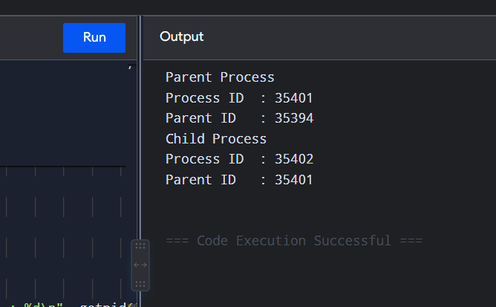
Parent Process
Process ID : 2450
Parent ID : 2100
Child Process
Process ID : 2451
Parent ID : 2450
RESULT
Thus, a new process was successfully created using fork() and the process ID and parent process ID were displayed using getpid() and getppid().

2. Copy Content of One File to Another
AIM
To identify and implement the system calls used to copy the contents of one file to another.
PROGRAM
#include <stdio.h>
#include <fcntl.h>
#include <unistd.h>
#include <stdlib.h>
int main()
{
int source, destination;
char buffer[1024];
ssize_t n;
source = open("source.txt", O_RDONLY);
if (source < 0)
{
perror("Source file");
return 1;
}
destination = open("destination.txt",
O_WRONLY | O_CREAT | O_TRUNC, 0644);

if (destination < 0)
{
perror("Destination file");
close(source);
return 1;
}
while ((n = read(source, buffer, sizeof(buffer))) > 0)
{
write(destination, buffer, n);
}
close(source);
close(destination);
printf("File copied successfully.\n");
return 0;
}
SAMPLE OUTPUT
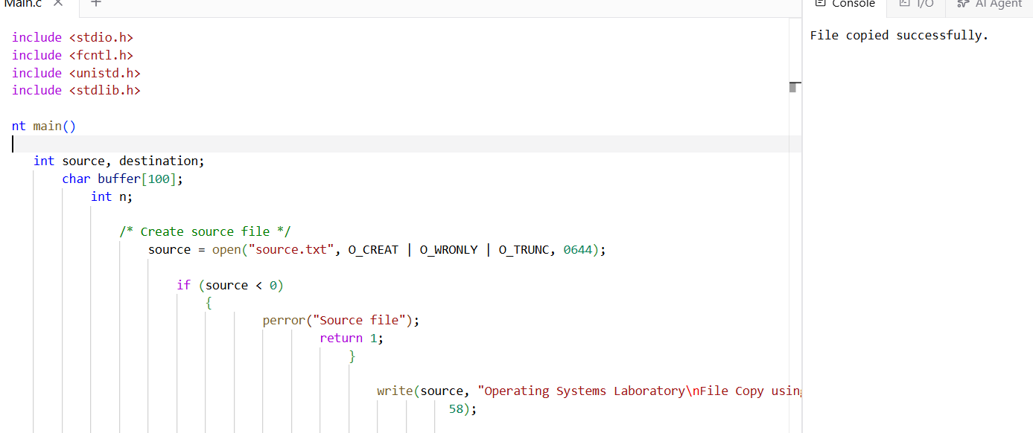
RESULT
Thus, the contents of the source file were successfully copied to the destination file using open(), read(), write(), and close() system calls.

3. FCFS CPU Scheduling
AIM
To implement the First Come First Served (FCFS) CPU scheduling algorithm using C, assuming all processes arrive at time 0 and no process waits for I/O.
PROGRAM
#include <stdio.h>
int main()
{
int n, i;
int bt[20], wt[20], tat[20];
float avgwt = 0, avgtat = 0;
printf("Enter number of processes: ");
scanf("%d", &n);
for (i = 0; i < n; i++)
{
printf("Enter burst time for P%d: ", i + 1);
scanf("%d", &bt[i]);
}
wt[0] = 0;
for (i = 1; i < n; i++)
wt[i] = wt[i - 1] + bt[i - 1];
for (i = 0; i < n; i++)
{
tat[i] = wt[i] + bt[i];
avgwt += wt[i];
avgtat += tat[i];
}

printf("\nProcess\tBT\tWT\tTAT\n");

for (i = 0; i < n; i++)
printf("P%d\t%d\t%d\t%d\n",
i + 1, bt[i], wt[i], tat[i]);

printf("\nAverage Waiting Time = %.2f", avgwt / n);
SAMPLE INPUT
Enter number of processes: 4
Enter burst time for P1: 5
Enter burst time for P2: 3
Enter burst time for P3: 8
Enter burst time for P4: 6

SAMPLE OUTPUT
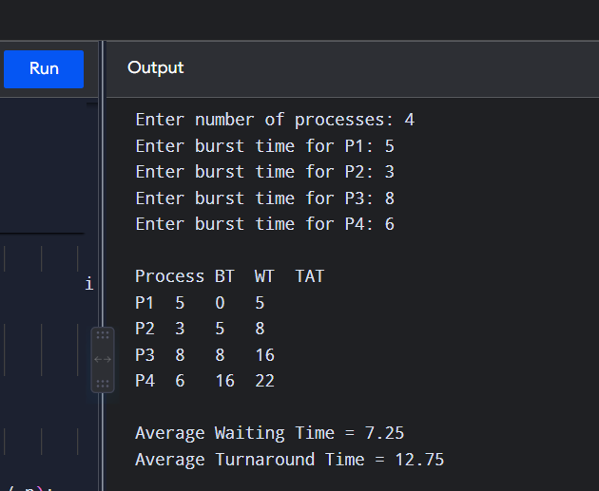

RESULT
Thus, the FCFS CPU scheduling algorithm was successfully implemented and the average waiting time and turnaround time were calculated.

4. Shortest Job First Scheduling
AIM
To implement a scheduling algorithm that selects the waiting process having the smallest execution time.
PROGRAM
#include <stdio.h>
int main()
{
int n, i, j, temp;
int bt[20], p[20], wt[20], tat[20];
float avgwt = 0, avgtat = 0;
printf("Enter number of processes: ");
scanf("%d", &n);
for (i = 0; i < n; i++)
{
p[i] = i + 1;
printf("Enter burst time for P%d: ", i + 1);
scanf("%d", &bt[i]);
}
for (i = 0; i < n - 1; i++)
{
for (j = i + 1; j < n; j++)
{
if (bt[i] > bt[j])
{
temp = bt[i];
bt[i] = bt[j];
bt[j] = temp;
temp = p[i];
p[i] = p[j];
p[j] = temp;
}
}
}
wt[0] = 0;
for (i = 1; i < n; i++)
wt[i] = wt[i - 1] + bt[i - 1];
for (i = 0; i < n; i++)
{
tat[i] = wt[i] + bt[i];
avgwt += wt[i];
avgtat += tat[i];
}
printf("\nProcess\tBT\tWT\tTAT\n");
for (i = 0; i < n; i++)
printf("P%d\t%d\t%d\t%d\n",
p[i], bt[i], wt[i], tat[i]);
printf("\nAverage Waiting Time = %.2f\n", avgwt / n);
printf("Average Turnaround Time = %.2f\n", avgtat / n);
return 0;
}
SAMPLE INPUT
Enter number of processes: 4
Enter burst time for P1: 6
Enter burst time for P2: 2
Enter burst time for P3: 8
Enter burst time for P4: 3
SAMPLE OUTPUT
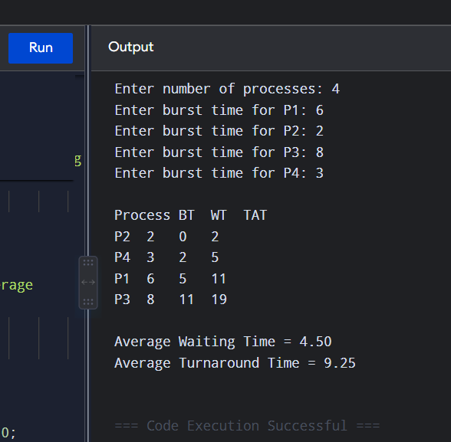
RESULT
Thus, the Shortest Job First scheduling algorithm was successfully implemented.
5. Non-Preemptive Priority Scheduling
AIM
To implement a scheduling algorithm that selects the waiting process with the highest priority.
Here, smaller priority number = higher priority.
PROGRAM
#include <stdio.h>
int main()
{
int n, i, j, temp;
int p[20], bt[20], pr[20], wt[20], tat[20];
float avgwt = 0, avgtat = 0;
printf("Enter number of processes: ");
scanf("%d", &n);
for (i = 0; i < n; i++)
{
p[i] = i + 1;
printf("Enter burst time and priority for P%d: ", i + 1);
scanf("%d %d", &bt[i], &pr[i]);
}
for (i = 0; i < n - 1; i++)
{
for (j = i + 1; j < n; j++)
{
if (pr[i] > pr[j])
{
temp = pr[i];
pr[i] = pr[j];
pr[j] = temp;
temp = bt[i];
bt[i] = bt[j];
bt[j] = temp;
temp = p[i];
p[i] = p[j];
p[j] = temp;
}
}
}
wt[0] = 0;
for (i = 1; i < n; i++)
wt[i] = wt[i - 1] + bt[i - 1];
for (i = 0; i < n; i++)
{
tat[i] = wt[i] + bt[i];
avgwt += wt[i];
avgtat += tat[i];
}
printf("\nProcess\tBT\tPriority\tWT\tTAT\n");
for (i = 0; i < n; i++)
printf("P%d\t%d\t%d\t\t%d\t%d\n",
p[i], bt[i], pr[i], wt[i], tat[i]);
printf("\nAverage Waiting Time = %.2f\n", avgwt / n);
printf("Average Turnaround Time = %.2f\n", avgtat / n);
return 0;
}
SAMPLE INPUT
Enter number of processes: 4
Enter burst time and priority for P1: 5 2
Enter burst time and priority for P2: 3 1
Enter burst time and priority for P3: 8 4
Enter burst time and priority for P4: 6 3
SAMPLE OUTPUT
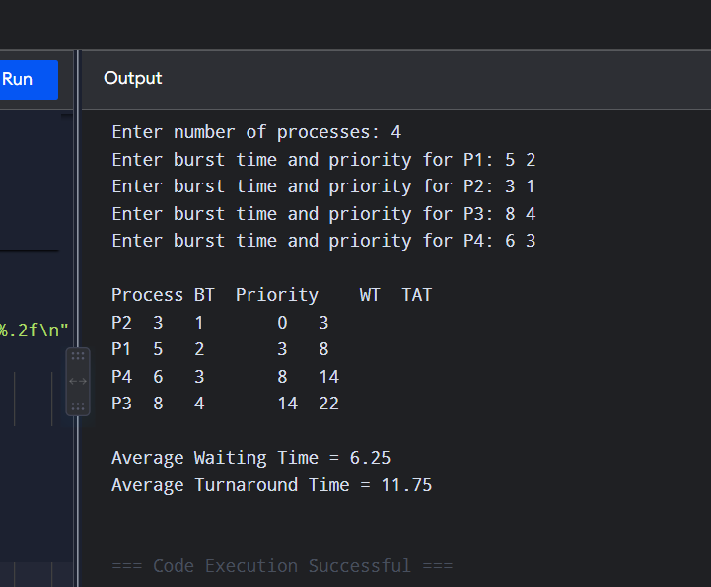
RESULT
Thus, the non-preemptive priority scheduling algorithm was successfully implemented.

6. Preemptive Priority Scheduling
AIM
To implement the preemptive priority CPU scheduling algorithm using C.
PROGRAM
#include <stdio.h>
#include <limits.h>
int main()
{
int n, i, time = 0, completed = 0;
int bt[20], rem[20], pr[20], ct[20], wt[20], tat[20];
float avgwt = 0, avgtat = 0;
printf("Enter number of processes: ");
scanf("%d", &n);
for (i = 0; i < n; i++)
{
printf("Enter burst time and priority for P%d: ", i + 1);
scanf("%d %d", &bt[i], &pr[i]);
rem[i] = bt[i];
}
while (completed < n)
{
int selected = -1;
int highest = INT_MAX;
for (i = 0; i < n; i++)
{
if (rem[i] > 0 && pr[i] < highest)
{
highest = pr[i];
selected = i;
}
}
if (selected == -1)
break;
rem[selected]--;
time++;
if (rem[selected] == 0)
{
ct[selected] = time;
completed++; } }
for (i = 0; i < n; i++)
{
tat[i] = ct[i];
wt[i] = tat[i] - bt[i];
avgwt += wt[i];
avgtat += tat[i];
}
printf("\nProcess\tBT\tPriority\tWT\tTAT\n");
for (i = 0; i < n; i++)
printf("P%d\t%d\t%d\t\t%d\t%d\n",
i + 1, bt[i], pr[i], wt[i], tat[i]);
printf("\nAverage Waiting Time = %.2f\n", avgwt / n);
printf("Average Turnaround Time = %.2f\n", avgtat / n);
return 0;
}
SAMPLE INPUT
Enter number of processes: 3
Enter burst time and priority for P1: 5 2
Enter burst time and priority for P2: 3 1
Enter burst time and priority for P3: 4 3
SAMPLE OUTPUT
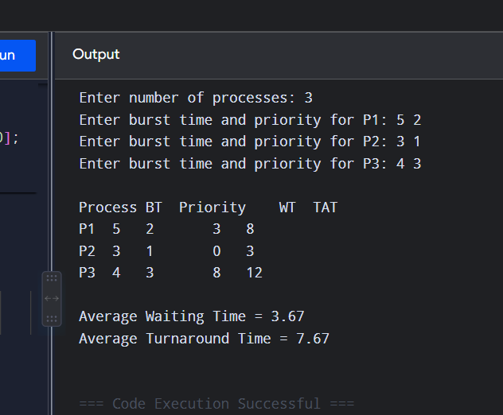

RESULT
Thus, the preemptive priority scheduling algorithm was successfully implemented.

7. Non-Preemptive SJF
AIM
To implement the Non-Preemptive Shortest Job First (SJF) scheduling algorithm using C.
PROGRAM
#include <stdio.h>
int main()
{
int n, i, j, time = 0, count = 0, min;
int bt[20], wt[20], tat[20], done[20] = {0};
float avgwt = 0, avgtat = 0;
printf("Enter number of processes: ");
scanf("%d", &n);
for (i = 0; i < n; i++)
{
printf("Enter burst time for P%d: ", i + 1);
scanf("%d", &bt[i]);
}
printf("\nProcess\tBT\tWT\tTAT\n");
while (count < n)
{
min = -1;
for (i = 0; i < n; i++)
{
if (!done[i] && (min == -1 || bt[i] < bt[min]))
min = i;
}
wt[min] = time;
time += bt[min];
tat[min] = time;
done[min] = 1;
count++;
avgwt += wt[min];
avgtat += tat[min];
printf("P%d\t%d\t%d\t%d\n",
min + 1, bt[min], wt[min], tat[min]);
}
printf("\nAverage Waiting Time = %.2f\n", avgwt / n);
printf("Average Turnaround Time = %.2f\n", avgtat / n);
return 0;
}
SAMPLE INPUT
Enter number of processes: 4
Enter burst time for P1: 6
Enter burst time for P2: 2
Enter burst time for P3: 8
Enter burst time for P4: 3
SAMPLE OUTPUT
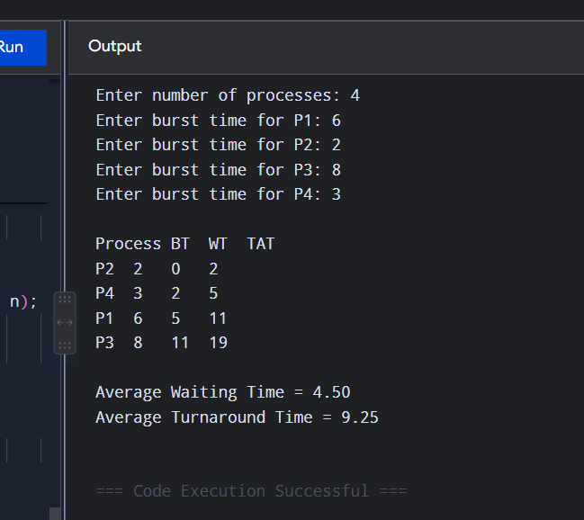
RESULT
Thus, the Non-Preemptive SJF algorithm was successfully implemented.

8. Round Robin Scheduling
AIM
To implement the Round Robin CPU scheduling algorithm using C.
PROGRAM
#include <stdio.h>
int main()
{
int n, i, tq, time = 0, remain;
int bt[20], rem[20], wt[20], tat[20];
float avgwt = 0, avgtat = 0;
printf("Enter number of processes: ");
scanf("%d", &n);
for (i = 0; i < n; i++)
{
printf("Enter burst time for P%d: ", i + 1);
scanf("%d", &bt[i]);
rem[i] = bt[i];
}
printf("Enter time quantum: ");
scanf("%d", &tq);
remain = n;
while (remain > 0)
{
for (i = 0; i < n; i++)
{
if (rem[i] > 0)
{
if (rem[i] <= tq)
{
time += rem[i];
rem[i] = 0;
tat[i] = time;
wt[i] = tat[i] - bt[i];
remain--;
}
else
{
rem[i] -= tq;
time += tq;
}
}
}
}
printf("\nProcess\tBT\tWT\tTAT\n");
for (i = 0; i < n; i++)
{
avgwt += wt[i];
avgtat += tat[i];
printf("P%d\t%d\t%d\t%d\n",
i + 1, bt[i], wt[i], tat[i]);
}
printf("\nAverage Waiting Time = %.2f\n", avgwt / n);
printf("Average Turnaround Time = %.2f\n", avgtat / n);

return 0;
}
SAMPLE INPUT
Enter number of processes: 3
Enter burst time for P1: 5
Enter burst time for P2: 4
Enter burst time for P3: 2
Enter time quantum: 2
SAMPLE OUTPUT
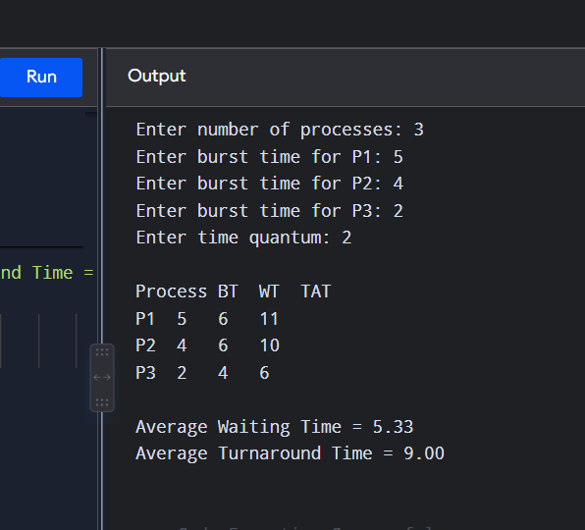
RESULT
Thus, the Round Robin scheduling algorithm was successfully implemented.

9. Inter-Process Communication Using Shared Memory
AIM
To illustrate Inter-Process Communication (IPC) using shared memory.
PROGRAM
#include <stdio.h>
#include <stdlib.h>
#include <unistd.h>
#include <sys/ipc.h>
#include <sys/shm.h>
#include <sys/wait.h>
int main()
{
int shmid;
char *shared;
shmid = shmget(IPC_PRIVATE, 1024, IPC_CREAT | 0666);
if (shmid < 0)
{
perror("shmget");
return 1;
}
shared = (char *)shmat(shmid, NULL, 0);
if (shared == (char *)-1)
{
perror("shmat");
return 1;
}
if (fork() == 0)
{
sprintf(shared, "Hello from Child Process");
shmdt(shared);
exit(0);
}
else
{
wait(NULL);
printf("Parent received: %s\n", shared);
shmdt(shared);
shmctl(shmid, IPC_RMID, NULL);
}
return 0;
}
SAMPLE OUTPUT
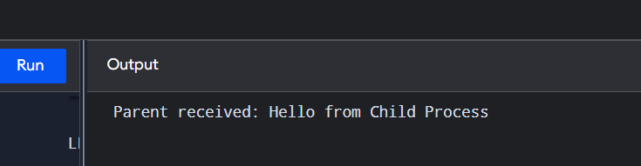
RESULT
Thus, communication between parent and child processes was successfully achieved using shared memory.

10. Inter-Process Communication Using Message Queue
AIM
To illustrate Inter-Process Communication using a message queue.
PROGRAM
#include <stdio.h>
#include <stdlib.h>
#include <sys/ipc.h>
#include <sys/msg.h>
#include <unistd.h>
#include <sys/wait.h>

struct message
{
long type;
char text[100];
};

int main()
{
int msgid;
struct message msg;

msgid = msgget(IPC_PRIVATE, IPC_CREAT | 0666);

if (msgid < 0)
{
perror("msgget");
return 1;
}
if (fork() == 0)
{
msg.type = 1;
sprintf(msg.text, "Hello from Child Process");
msgsnd(msgid, &msg, sizeof(msg.text), 0);
exit(0);
}
else
{
wait(NULL);

msgrcv(msgid, &msg, sizeof(msg.text), 1, 0);
printf("Parent received: %s\n", msg.text);
msgctl(msgid, IPC_RMID, NULL);
}

return 0;
}
SAMPLE OUTPUT
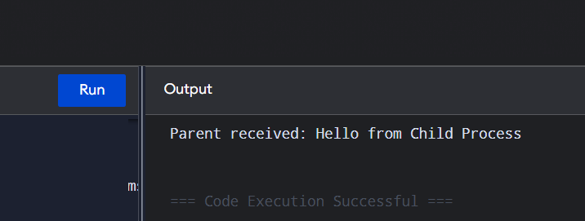
Parent received: Hello from Child Process
RESULT
Thus, IPC between processes was successfully implemented using a message queue.

